
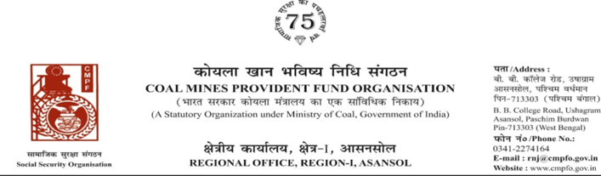
Ref. : CPF/118/Misc/RNJ/LC/OUT/R-I/ASN/ 896 Dated :28/06/2025
To,

The Regional Commissioner
Coal Mines Provident Fund Organisation
PO-Jaripatka, Dist-Nagpur -440014
Maharashtra)

Sub- :Inter Regional Transfer of Ledger Card, DA, PS
Ref:-CPF/NAG/LC/REQ/NAG/6 (VV Stt.03/2025)396 Dated :02/06/2025

Sir,
In view of the revised procedure prescribed in procedure office order No-230 Dated-12/02/1973 of CMPF Commissioner, Dhanbad, I am to state that the ledger card of the following member is forwarded to your office as he is working under jurisdiction of your region.
It is ensured that the posting in the ledger card are dully completed for the periods for which the member was contributing in this region.
SL. No | Name of the member | CMPF A/C No | Name of the colly wheremember worked in this region | Name o the colliery where member working in your region
1 | Ganesh Tukaram Diwate | MGM/3/181 | Sonepur Bazari, AHQ (Rnj/34,Rnj/41)L.C. NOT Available In This Unit Please. | NGP/6 (VV Stt. 03/2025)

Encl. :As above

Yours faithfully,
.

Assistant Commissioner









Ref:- CPF/118/Misc/RNJ/LC/OUT/R-I/ASN/ Date :27/06/2025

To,

The Regional Commissioner
Coal Mines Provident Fund
Ranchi , R-II
Ranchi (jharkhand)
PIN-834001

Sub- :Inter Regional Transfer of Ledger Card, DA, PS -3 & 4
Ref:-
Sir,
In view of the revised Procedures prescribed in Procedure Office Order No-35 Dated-12.02.1975 of CMPF Commissioner,Dhanbad, I am to state that the Ledger Cards of the following members along with Declaration in Form "A" Form-I (Pen),PS-3 & 4 may kindly be forwarded to this office as the member(s) is /are working in this region.
It may kindly be ensured that the posting in the Ledger Cards may be made updated for the periods the member was working in your Region.
Member will be superannuate on 31stJanuary, 2025. Refund claim received to this office under Mission Biswas.
SL. No | Name of the member | CMPF A/C No | Name of the colly wheremember worked in this region | Name o the colliery where member working in your region
1 | Sri Malay Chandan Chandra | KGL/17/1602 | Kathara Colliery,KitharaArea,CCL | Kumardihi‘B’Colliery  (RNJ/18)

Encl. :Posting Details

Yours faithfully

Assistant Commissioner

Letter No - CPF/118/Misc/Ext-out/R-I/ASN/ Dated-27/06/2025

To,
The regional Commissioner
CMPFO,SBP
P.O.-Jagrutivihar, Dist.-Sambalpur
State - Odisha, PIN- 768020

Sub:- Supply of Extract of "VV" statement

Ref:-

Sir,

On the subject and reference cited above,enclosed please find herewith the extract in r/o-
Sri Kishore Ram Ratan CMPF A/C No- BBSR/23/30 as required. Ledger Card is not available in this region.

Encl- As above

Yours faithfully

Assistant Commissioner



